Stanley Adom

Talen Phillips

Dustin Maclay

Lab 9: Verify Logic Component Via Automated Test

2APR2013

**Introduction**

In this lab, students were asked to create a circuit and program to test logic gates with the Arduino microcontroller. The possible gates include 2-input NAND, 2-input NOR, 2-input AND, 2-input OR, and a 2-input XOR.

**Procedure**

First, the students determined constructed a simple circuit as shown in the picture:

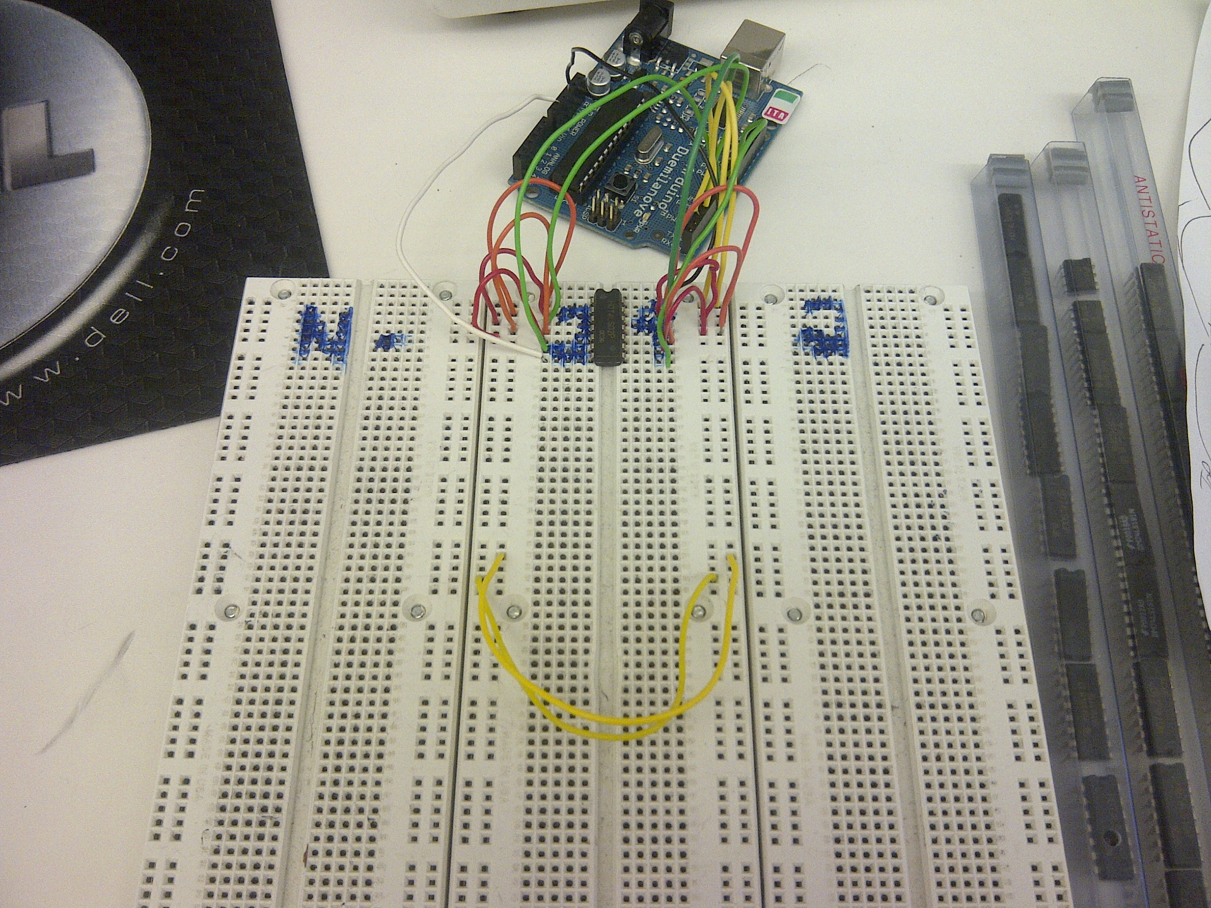

The green wires are the outputs of the logic gates. The red and orange wires are the 2 shared inputs among all the gates. The black and white wires are the vcc and ground. Please note that this circuit was not fully utilized. It could have tested all gates on a single chip, but the students ran out of time, and weren’t able to implement the appropriate code to execute the test. Only one input was tested.

Next, the students wrote a short program to interpret the input from the serial interface and use it to determine which type of gate was being tested. The method involves taking the taking the first two letters, and running them through a series of if statements, then inputting the correct code to the logic gates, and comparing the output to a predetermined table:

int inputA = 2;

int inputB = 3;

int output1 = 4;

int i, gate, result;

int serialinput1,serialinput2;

int in_arr[4][2] = {

{0,0},

{0,1},

{1,0},

{1,1}

};

int test_arr[4][5] = {

{0,0,0,1,1},

{0,1,1,1,0},

{0,0,0,1,1},

{1,1,0,0,0}

};

void setup() {

// initialize serial communication:

Serial.begin(9600);

// initialize the pins:

pinMode(inputA, OUTPUT);

pinMode(inputB, OUTPUT);

pinMode(output1, INPUT);

}

void loop() {

// read the sensor:

Serial.println("Enter a gate to be tested: ");

while (Serial.available() != 1);

serialinput1 = Serial.read();

while (Serial.available() != 1);

serialinput2 = Serial.read();

if ((serialinput1=='a')||(serialinput1=='A')) gate = 0; //AND

if ((serialinput1=='o')||(serialinput1=='O')) gate = 1; //OR

if ((serialinput1=='x')||(serialinput1=='X')) gate = 2; //XOR

if ((serialinput1=='n')||(serialinput1=='N')){

if ((serialinput2=='a')||(serialinput2=='A')) gate = 3; //NAND

else gate = 4; //NOR

}

Serial.println(gate);

result = 1;

Serial.println("Testing...");

for(i=0;i<4;i++)

{

digitalWrite(inputA,in_arr[i][0]);

digitalWrite(inputB,in_arr[i][1]);

delay(50);

if((digitalRead(output1)) != (test_arr[gate][i])) result = 0;

}

if (result==1) Serial.print("Passed.");

else Serial.print("Failed.");

}

Here is a screenshot of the running code:

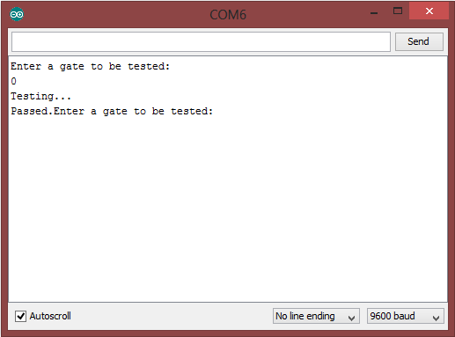

**Conclusion**

In this lab, the students learned how to use the Arduino microcontroller to take data from user input in the serial monitor. They used the data to determine which test would be performed. The way the data was taken was a little awkward, since any letters would be accepted as values, and any input with more than 3 digits would cause the program to react erratically. It may be possible to use an array to take an input of varying length and convert it into a string, but since the standard C library isn’t included in its entirety, the students would need to write their own function to execute that conversion.